**DATA ONLY CONTAINER (DATABASE-POSTGRES INSIDE DOCKER):**

Docker postgres image :

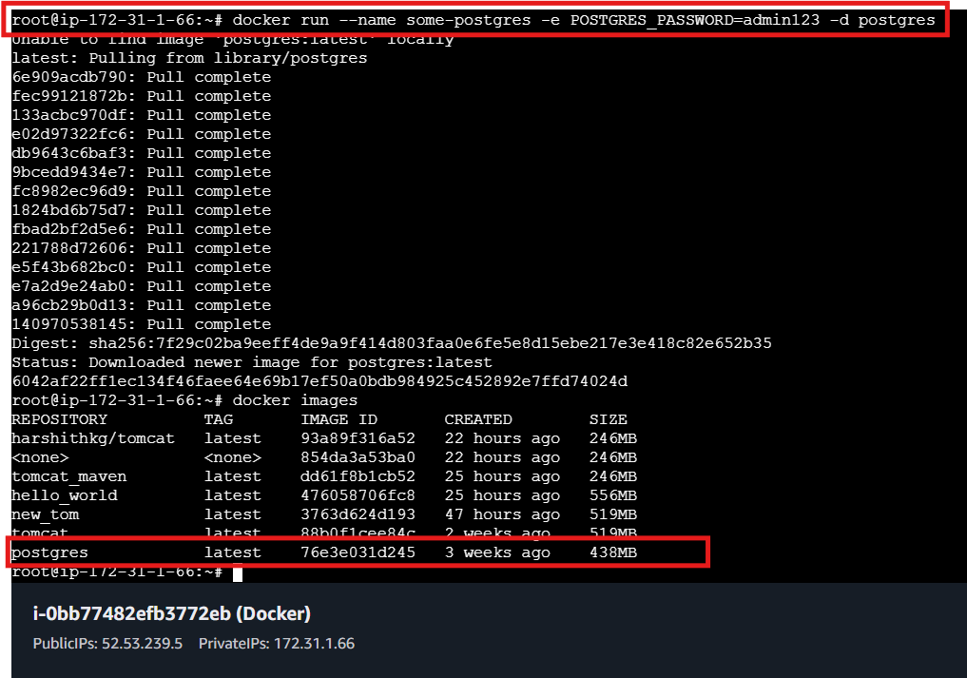

Data base list :

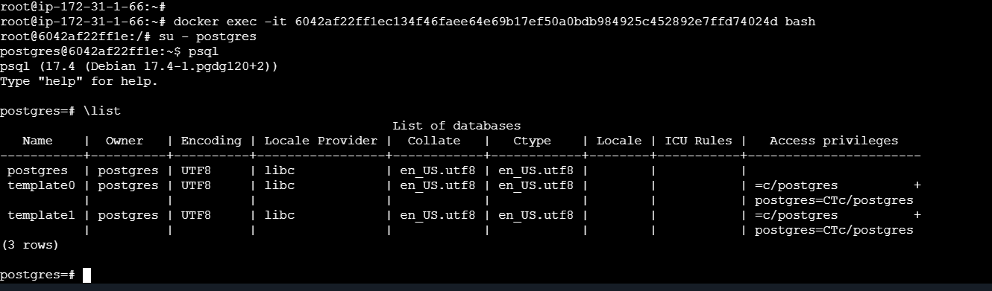

CREATE TABLE employees and contents within it (Rows and columns) :

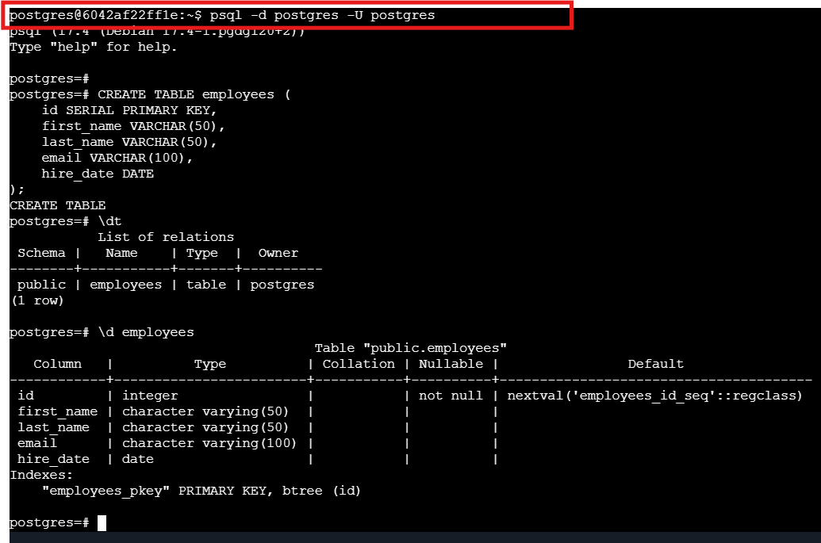

Create a new ubuntu image and run that image :

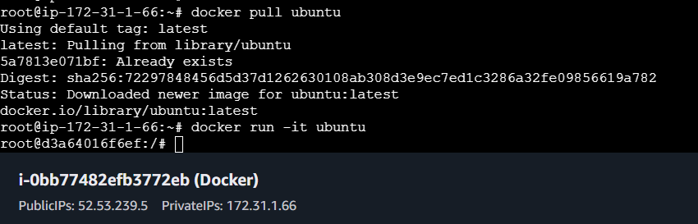

docker images and inspecting the postgres container for ip provided by docker daemon under Networks section :

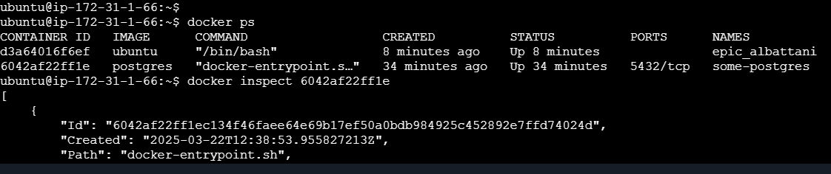

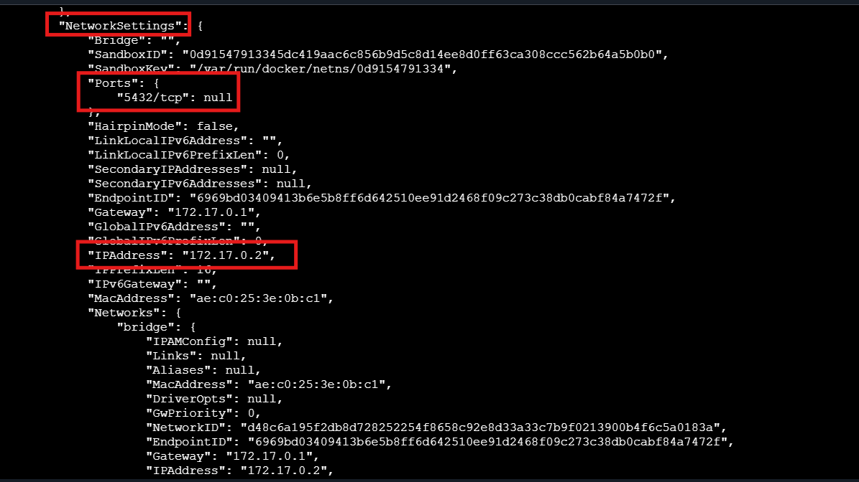

postgres configuration on ubuntu :

*Inside ubuntu container*

*Eg::\root@d3a64016f6ef:/#*

*apt update*

*apt install -y postgresql-client*

*psql -h 172.17.0.2 -p 5432 -d postgres -U postgres*

